Freescale Board Good Install

This is displayed when you plug in the board.

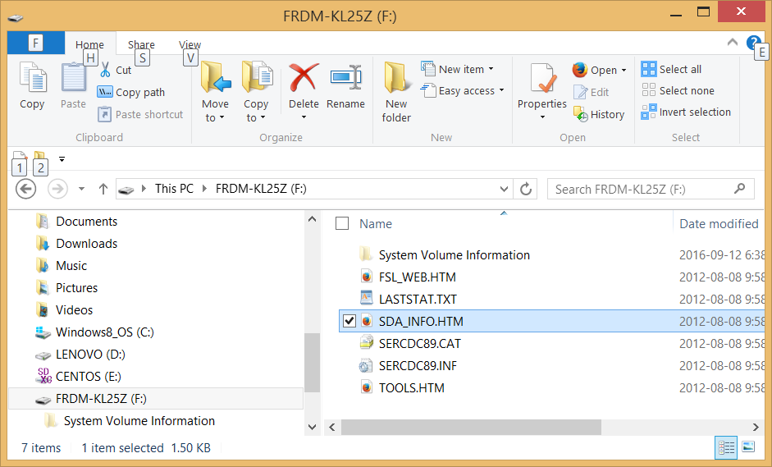

Double click on SDA_INFO.HTM to get:

|  |
| --- |
| **Your Hardware Information** |
| Board Name is: FRDM-KL25Z MicroBoot Kernel Version is: 1.01 Bootloader Version is: 1.11 Installed Application: PEMicro FRDM-KL25Z Mass Storage/Debug App Application Version is: 1.14 DUID is: 74823937-473181DF-375AF805-B66DE678 EUID is: 6AE3D036-A84B876D-1859DA22-947668D6 TUID is: 74823938-4732819C-3922E804-A46CDC77 TOA is: 86B6E505-A24C3690-637FDE17-0CFC42C0 TOA2 is: 86B6E505-472B8B3C-16D2E1CF-27FFE868 SUID is: 86B6E505-6C47961D-37239804-8003EC65   **Board registered to University of Colorado Boulder.** |

Not Good looks like this:

|  |
| --- |
| **Your Hardware Information** |
| Board Name is: FRDM-KL25Z MicroBoot Kernel Version is: 1.05 Bootloader Version is: 1.09 Application Version is: 0.00 DUID is: 2F533938-97B381BE-37801819-B860E678 EUID is: 27D1A239-15998750-18813A0E-925968D6 TUID is: 74823938-473281A5-375E980F-B85CE678 TOA is: 86B6E505-F4EC35F6-41E6B687-13C314A6 TOA2 is: 86B6E505-8F2592E8-CDE430D7-488BB005 SUID is: 86B6E505-6C47A61D-37239804-8003EC65 |

To get to the bootloader, hold down the reset button while plugging into the lower USB port. You should see this:

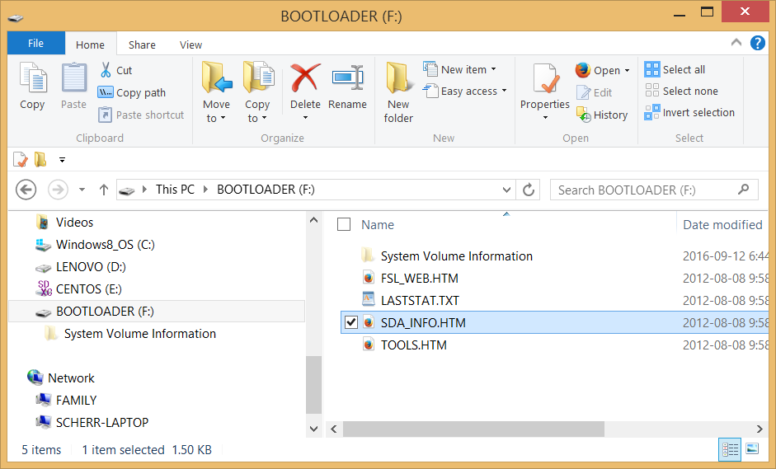

See the document “PEMicroBootloaderUpdate.docx to update the Bootloader.

Sometimes the bootloader update to 1.14 takes several minutes, so be patient and wait for the green LED to blink at 1 Hz. If it blinks faster, the copy operation failed and you must try again on a Win7 or Linux machine.

After you get the boot version to say 1.14, you are ready for the next step.

Unplug the board, plug it in again, and now you should see the bootloader.

Download the mbed firmware upgrade [20140530_k20dx128_kl25z_if_opensda](https://developer.mbed.org/media/uploads/sam_grove/20140530_k20dx128_kl25z_if_opensda.s19.zip)

After you copy the .s19 file to the Bootloader folder, unplug the board and replug it to get:

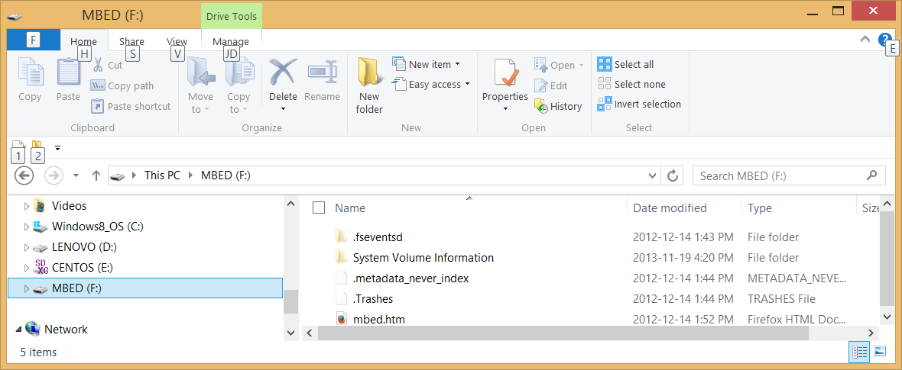

Double click on mbed.htm to start the mbed online IDE interface. Do the mbed portion of Homework B first, and then the Lab_Exercise_1.